SBC adds extra modules to its E-Line range

Murten, July 2018 – The E-Line S-Series RIO control modules from Saia Burgess Controls (SBC) were specially developed for installation in electrical sub-distribution systems and are ideal for automation tasks in HVAC equipment and the electrical trade. Two new modules have now been added to the existing range, allowing further input and output combinations for additional applications.

SBC now offers the new PCD1.B5010-A20 module for installations requiring integrated fire dampers. A 24V input module, it can be used wherever digital 24V inputs and relays are needed.

The new PCD1.G210-A10 rounds off the range. Up until now, only an analogue output module and a combined analogue input/output module were available. The new universal input module is a low-cost alternative where no analogue outputs are needed as it does not offer functions that are not required. PCD1.G2100-A10 can be configured in analogue or digital fashion.

Thanks to their compact, space-saving design, all E-Line S-Series RIO products can be installed in the smallest of spaces. With their push-in terminals, they can be wired and put into operation quickly and without the use of tools. Programming too is very easy. The FBox libraries and the Saia PG5 Web Editor Templates which were specially developed for the E-Line product family allow efficient engineering and reduce the time required. The modules have a long operating life and are extremely reliable. Via the Saia PCD controller's web interface, a number of devices can also be remote-operated using a touch panel.

Images (SBC, no charge for reproduction when source is cited):

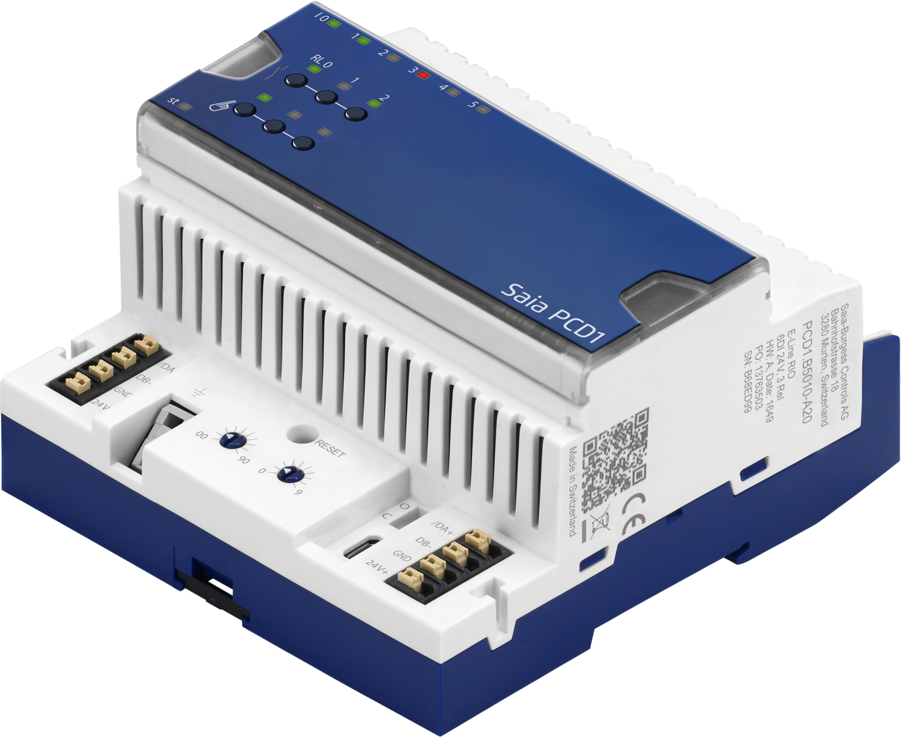 | A 24V input module has been added to the E-Line S-Series RIO. The new PCD1.B5010-A20 is particularly suitable for the integration of fire dampers.
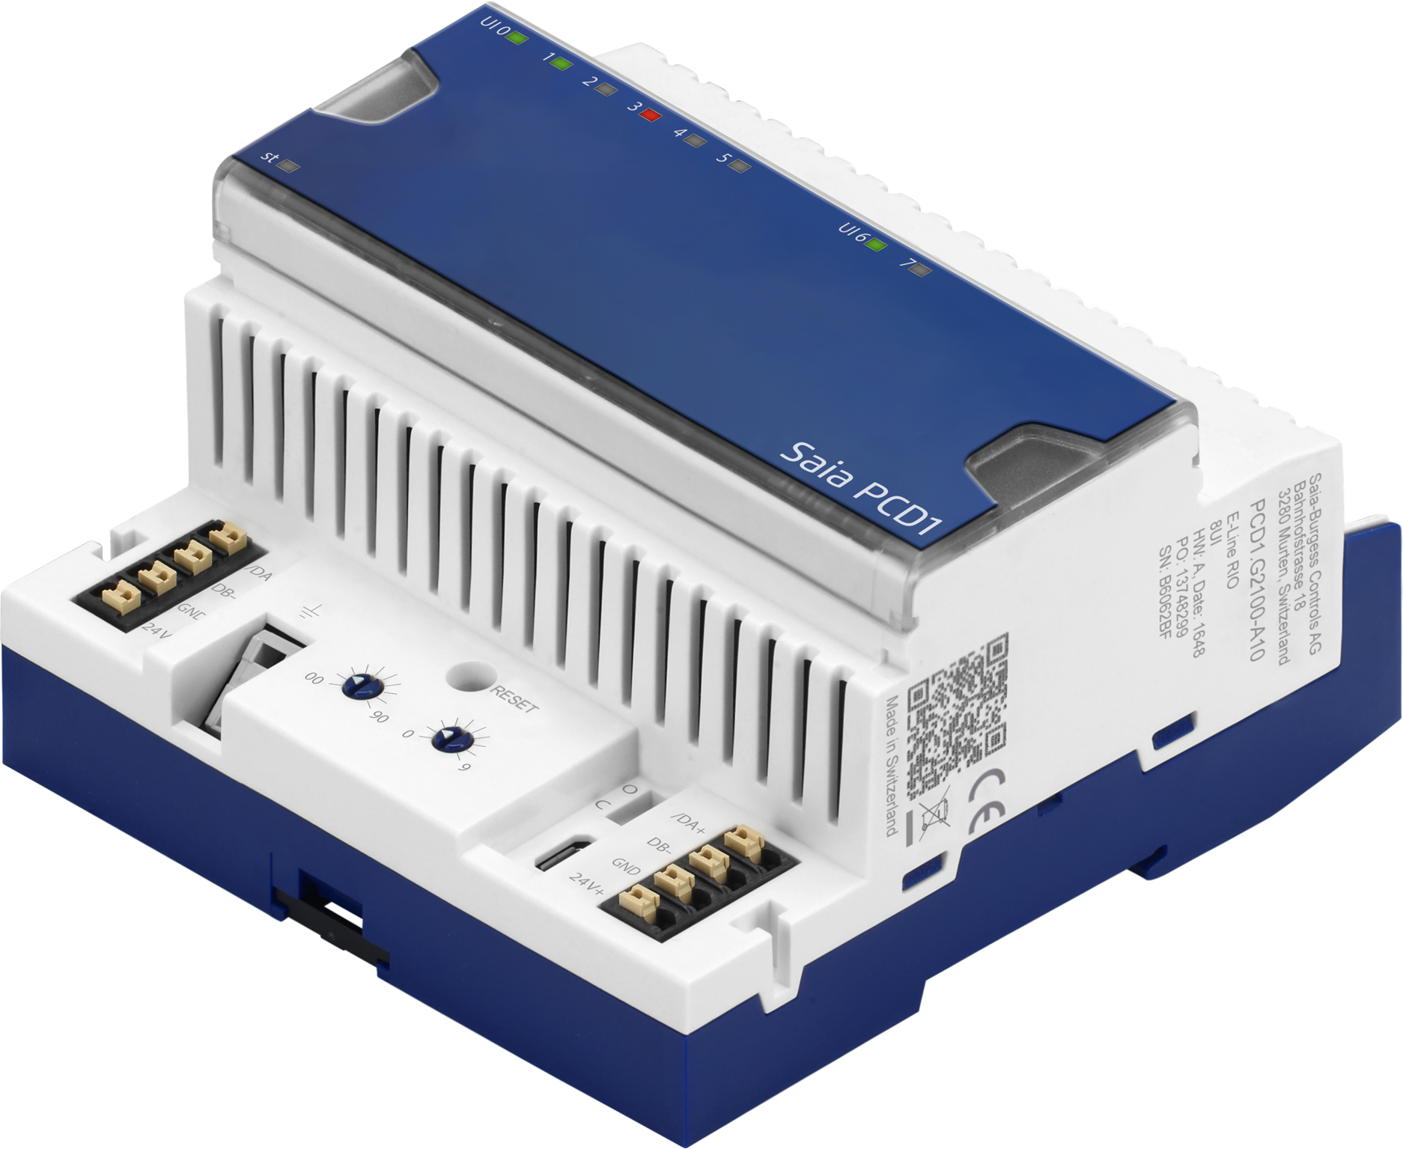 | The new PCD1.G2100-A10 analogue/digital input module rounds off the previous E-Line S-Series RIO range and offers a low-cost alternative for applications where no outputs are required.

About Saia-Burgess Controls AG:
Saia-Burgess Controls AG (www.saia-pcd.com) is a wholly-owned subsidiary of Honeywell International. It has developed, produced and marketed electronic components as well as measurement and control systems since 1950. The products have an extremely long service life with a life cycle of up to 25 years and are mainly used in heating, ventilation, air conditioning, energy management and water systems. A further important pillar is OEM production. SBC produces around 2 million I/O points, 35,000 CPUs and more than 700,000 small devices each year to the most exacting quality standards. With annual turnover of EUR 65 million and more than 250 employees, the Swiss company headquartered in Murten is a valued manufacturer of infrastructure automation solutions.

Saia-Burgess Controls AG Ansel & Möllers GmbH
Press office PR agency
Bahnhofstrasse 18 König-Karl-Str. 10
3280 Murten 70372 Stuttgart
Switzerland Germany

T +41 26 580 30 00 T +49 711 925 45 281
presse@saia-pcd.com j.haubold@anselmoellers.de
www.saia-pcd.com www.anselmoellers.de

SBC Deutschland GmbH
Siemensstrasse 3
63263 Neu-Isenburg

T +49 6102 20 25 0
marketing.de@saia-pcd.com
www.saia-pcd.de

